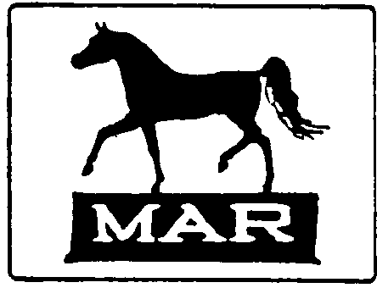

Betsy Andrews – MAR Show Manager – 115 Earle Branch Rd. – Centreville, MD 21617 – fpmvendetta@yahoo.com

Hello!

Thank you for entering the 38th Annual Mid-Atlantic Regional Horse Show. This promises to be an action packed weekend totally devoted to model horses.

Judges are still needed. If you can help out by judging a division/section, please let me know. Those who won a grand/reserve last year – please consider volunteering! That’s the only way to keep the show going. Please check the website to see what divisions/sections are still open. (http://woodlandfarm1976.weebly.com)

The initials that you should use on your tags are also listed on the website – as well as what day you are participating and table space requested. Please use the three initials on all tags and cards; many of you have similar initials, and if you use only those of your first and last name, they may be the same as another fellow shower. It’s fine to have your full name listed on the tag as well, but your initials MUST be on them Please check the website to make sure your information is correct.

Donations are being accepted to the auction and raffle, please contact me if you’d like to donate. We have a few – and could use more. A complete listing will be sent to each MAR participant in mid-March, and a listing will be available on the website in the next couple weeks.

If you have a quick question about MAR, please email me at: FPMVendetta@yahoo.com. Please don’t panic if you don’t hear back from me right away – I’m not on email anywhere near 24/7. Email is not always checked on weekends, and even during the week it might take a day or two to get back to you.

That’s it for now. I’ll try to send out a “pre-show” letter the week before MAR with any updates. Also check the website for updates. Looking forward to seeing you in March!

Betsy

